**DATA PREPROCESSING**

|  |  |
| --- | --- |
| Team ID | PNT2022TMID07729 |
| Project Name | Crude Oil Price Prediction |

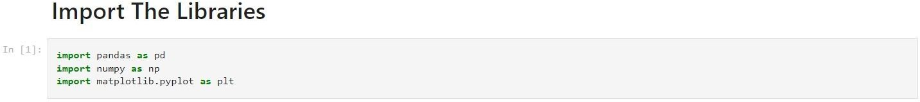

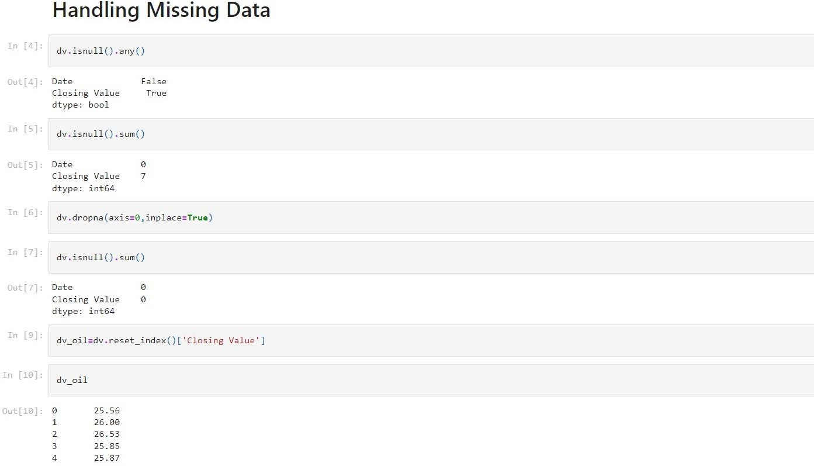Importing the dataset

